# LAB 1.1.2a

2. In a word document, identify and describe the three elements of the CIA Triad.

|  |  |  |
| --- | --- | --- |
| Confidentiality | Integrity | Availability |
| Confidentiality restricts access to sensitive information, ensuring only authorized individuals can access it. Data is categorized based on potential damage from unauthorized disclosure, aiming to prevent sensitive information from falling into the wrong hands. | Assures that information is trustworthy and accurate. Can only be altered by authorized individuals. Prevents errors, accidental deletion, and Detects changes from non-human events like a server crash. | Guarantees reliable access to information by authorized individuals. Ensured by maintaining hardware repairs, properly functioning OS, Upgrades, and safeguards against data loss, bottle necks or interruptions |

3. Describe why each of the three principles are important.

- **Confidentiality**: protects sensitive data from unauthorized access, ensuring privacy, preventing identity theft, and safeguarding critical business or personal information.

- **Integrity**: ensures that data is accurate and trustworthy, enabling reliable decision making and preventing errors, inefficiencies, or disastrous outcomes.

- **Availability**: ensures that authorized users can access necessary information and systems when needed, maintaining operational continuity and minimizing disruptions.

4. Describe a security mechanism that could be used for each of the three elements.   
For example: A backup generator could be used to ensure availability of devices in   
the case of a power outage.

**Confidentiality**: encryption can be implemented to ensure that data is stored can only be accessed by authorized people. Mantraps, RFID and Security Guards can also be implemented.

**Integrity**: Hashing can be used to ensure validity of data, files,apps.

**Availability**: Load balancing, Generators, UPS,s and multiple offsite backup servers can be used to ensure high availability.

5. For each of the following scenarios, identify which principle of the CIA triad has be   
violated:

|  |  |
| --- | --- |
| Principle Violated | Scenario |
| Availability | When Clint leaves the room, Wade unplugs his router so  he doesn’t have WiFi access. |
| Confidentiality | Pepper uses a cleverly placed USB device with a  keylogger to capture Tony’s online banking password. |
| Integrity | Wanda rewrites the magnetic strip on a gift card to  modify the amount from $10 to $100. |
| Availability | Peter is attempting to work on his Financial Aid  application online, when the website crashes and he is  unable to turn in his documents by the midnight deadline. |
| Integrity | Mary’s doctor pulls up her medical records, but her  allergy to lactose is no longer included in her patient file. |
| Confidentiality | While Master Wong is away, Stephen manages to steal a  book of ancient texts from the Kamar-Taj library. |

6. Another pillar of Information Security relates to Authentication. Give three   
examples of forms of authentication. For example: a username and password.

Biometric scanners

2FA

Security Key  
   
7. The final of the Five pillars of Information Security relates to Non-repudiation. To   
“repute” something means to deny a message's validity; Non-repudiation would be   
assurance that the message was valid and that cannot be disputed.   
   
A great real-world example of this comes from USPS Certified Mail. Read the   
article and answer the following questions regarding non-repudiation and this type   
of mailing service: https://www.postgrid.com/what-is-certified-mail/

1. **How does USPS Certified Mail provide proof that the message was sent?   
   What kind of information is included in this proof?**

USPS Certified Mail provides proof that a message was sent through mail receipt and tracking number found on the right of PS Form 3800. The sender fills out the form and attaches it to the mailer. The barcode on the left is affixed to the mail, they also offer electronic confirmation.

1. **How does USPS Certified Mail provide proof that the message was   
   successfully delivered? What kind of information is included in this proof?**

USPS confirms successful delivery by recipients’ signature which is mailed back to the sender for proof which is stored for up to 2 years. With the electronic option the signature is created and converted to PDF which is then emailed to the sender. The tracking number is also used a proof

1. List three examples of when Certified Mail is used.

- Contracts

-Notices

-Sensitive or confidential information

d. Can Certified Mail be delivered without a signature?

No Certified Mail cannot be delivered without a signature

e. How does Certified Mail relate to the principle of non-repudiation?

Certified Mail relates to the principle of non-repudiation because it provides a verifiable record of both the sender and the recipient’s involvement in the transaction. So it ensures that someone cannot deny authenticity.

# Implement principles of cybersecurity to secure a browser

4.

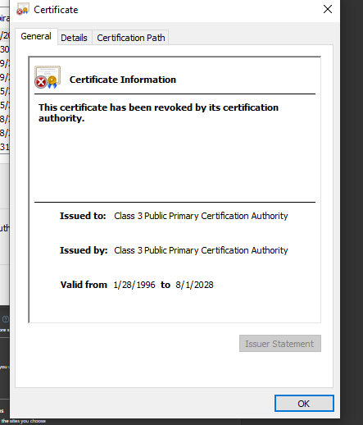

6.

a. Username and password

b. Cards, identity , and Secure notes

c. Ctrl/CMD + Shift + L

# Reflection

1. Built in Ad and tracker blocking, HTTPS Everywhere , Shields, Privatebrowsing with Tor, Finger print protection, cookie and script blocking, Native Support for Privacy-Preserving Search Engines, Phishing and Malware Protection, Cross-Site Tracking Protection , Granular Permission controls and Automatic Updates.
2. I recommend Brave for Smiles for Miles due to its privacy first design and strong security measures by default, Which is ideal for protecting customer information.